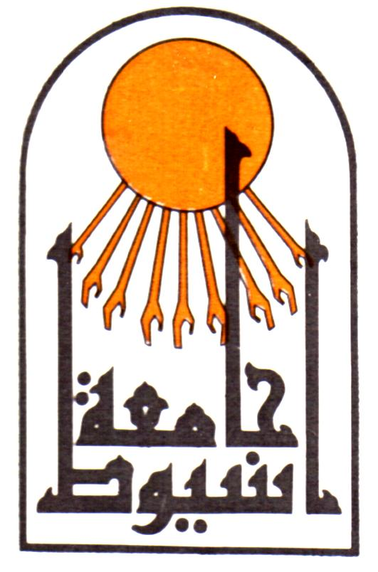

Assiut University
Faculty of Medicine
Dept. of orthopedics surgery

CURRICULUM VITAE

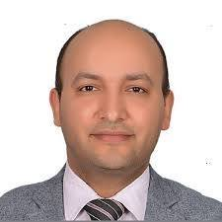

Mohamed Khaled Hassan Ahmed
lecturer of Orthopedics surgery and traumatology,
Assiut University Hospitals and School of Medicine
Assiut, Egypt
Tel: Home (+2088) 2303034
Office (+2088)2413345, (+2088) 2413343
Fax: (+2088)2333327
Mobile: (+2)0102616115
E-Mail: mohamedkhaledortho@gmail.com
Last update November 2017
- Name (in passport):
Mohamed Khaled Hassan Ahmed

- First name: Mohamed
Last name: Khaled
- Birthdate: Nov 12th, 1979.
- Sex: Male.
- Nationality: Egyptian.
- Place of Birth: Assiut, Egypt.
- Marital Status: Married.
- Professional Title and Address:
lecturer of Orthopedics surgery and traumatology, Faculty of Medicine, Assiut University, Egypt.
- Present occupation:
lecturer of Orthopedics surgery and traumatology, Assiut University Hospital, Assiut University, Egypt.
- Subspecialty:
Paediatric orthopedic surgery.
- Educational Background:
  - September 2002: M.B.B.Ch in Surgery and Medicine, Faculty of Medicine, Assiut University, Egypt. (With general grade of Excellent with honor).
  - October 2007: M.Sc. in Orthopedics surgery and Tarumatology Faculty of Medicine, Assiut University, Egypt.
  - 2013; MD in Orthopedic and Traumatology Faculty of medicine, Assiut University, Egypt

- Training Experience:
  - 3/2003 To 2/2004: House Officer, Assiut University Hospital, Assiut, Egypt.
  - 3/2004 up to 3/2007: Resident of Orthopedics surgery and traumatology, Assiut University Hospital, Assiut, Egypt.
  - 3/2007 up to 11/2007: Demonstrator of Orthopedics surgery and traumatology, Assiut University Hospital, Assiut, Egypt.
  - 12/2007 up to 6/2013: Assistant lecturer of Orthopedics surgery and traumatology, Assiut University Hospital, Assiut, Egypt.
  - 7/2013 up to date: lecturer of Orthopedics surgery and traumatology, Assiut University Hospital, Assiut, Egypt.

- Duties (2006 – up to date):
  - Performing orthopedic operations as previously detailed.
  - Teaching under graduate medical students of 6th year of Assiut University clinical rounds and clinical skills.
  - Teaching graduate students along the house officer- training program at our department.
  - Supervising and directing residents and fellows at our department in :( preoperative assessment and patient counseling- operative procedures - postoperative care.)
  - Helping in the research programs held at our department.
  - 24 hours shifts, twice a week, dealing with orthopedic emergencies and trauma.
  - 2 days on the outpatient clinic (dealing with about 100 patients daily).
  - Participation in the weekly seminar of our department.
  - Attending postgraduate teaching program healed twice weekly in our department
  - Attending journal club healed twice monthly in our department.
- Master degree research :
Surgical Treatment of perilunate dislocation and fracture dislocation(Essay).

- Doctoral degree research
Ponseti method in the management of congenital idiopathic clubfoot.
- Membership:
  - Egyptian Orthopedic Association
  - Assiut Childhood and Development Association. (Non for profit organization caring for handicapped children).
- Fellowships
1-Fellowship in the method of ilizarov in ospedale alessandro manzoni, lecco, italy. From july 2010 to october 31 2010 supervised by professor M.A.Catagni president o ASAMI Italy and head of orthopedic and traumatology depatement Alessandro Manzoni ospedale, lecco, Italy.
2-Fellowship in Arthroplasty,Pediatric Orthopedic and Foot and Ankle surgery in Ludwig Hause hospital , Wuertsburg, Germany. From 11/2012 up to 5/2013
- International courses
  - Attended Baltimore deformity course 2016

- General Interests and Skills
  - Computer work and Information Technology
  - Sport: Swimming, Running.
  - Primary language: Arabic.
  - Foreign Languages:
    - English: all medical studies and exams in English.
    - French: 3 years study in the secondary school.
- Publications
1-Percutaneous Needle Quadriceps Tenotomy For Treatment Of Idiopathic Congenital Dislocation Of The Knee. Mohamed Khaled, Kamal Elgafary, Wael E ladly.accepted for publication in current orthopedic practice May 2018.
2-Flexor hallucis longus transfer clinical outcome through a single incision for chronic Achilles tendon rupture. Hossam Abubeih, Mohamed Khaled, Waleed Riad Saleh, Galal Z. Said. International Orthopaedics, May 2018.
3-Ankle fusion in Charcot neuroarthropathy by narrow dynamic compression plate through anterior approach. Essam Elsherif, Hossam Abubeih, Mohamed Khaled, Galal Said, The Journal of Orthopedics Trauma Surgery and Related Research, March2018.
4-Rate of correction of angular deformities of the knee in skeletally immature patients by Eight-plate temporary hemiepiphysiodesis Mohamed Khaled, Nariman Abol Oyoun, Mohamed Ragab, Abdelkhalek Hafez, The Journal of Orthopedics Trauma Surgery and Related Research, March2018.
5-Submuscular locked plate for fixation of pediatric fracture femur using cluster technique. Mohamed Khaled, kamal elgafary, Mahmoud badran, Hatem Bakr. The Journal of Orthopedics Trauma Surgery and Related Research, June 2017.
6-Gradual Correction Of Severe Adolescent Tibia Vara By Ilizarov External Fixator. Kamal elgafary, Mohamed Khaled, Wael eladly. EFORT Geneva, June 2016.
7-Management of high-energy tibial plateau fractures by Ilizarov external fixator. Kamal El-Gafary,wael eldly,osama farouk, Mohamed Khaled, Marwa abdelaziz, Eur Orthop Traumatol.April 2013.
8- Ponseti method for management of neglected idiopathic clubfoot. Mohamed Khaled, Abdelkhalek Hafez, Maged Mostafa. Current Orthopedic Practice, March2013.

- Reviewer in Journal of Orthopaedic Surgery and Research
- References and certificates are available on demand.

